Multilingual Web Chat System



Submitted By: Hamna Imran

Supervised By: Ms. Memoona Afsheen

Department of Computer Sciences
Quaid-e-Azam University, Islamabad
(2021-2025)

Acknowledgment
First of all, I would like to express my heartfelt gratitude to my supervisor, Ms. Memoona Afsheen, for her guidance, encouragement, and support throughout my Final Year Project. Her constructive feedback and expertise have been invaluable in helping me complete this work.
I am also thankful to my peers and colleagues who provided constructive feedback and supported me along the way.
Lastly, I appreciate everyone who contributed, directly or indirectly, to the completion of this project. Your support means a lot to me.

Abstract

Language barriers are still one of the biggest hurdles for global teams. Most chat platforms don’t make it easy to talk across languages in real time, which slows down collaboration and creates frustration.

The Multilingual Web Chat System is built to fix that. Using the MERN stack with Google’s Translation API, it lets people speak or type in the language they’re most comfortable with, while the system instantly translates for the other side. Along with real-time translation, it supports media sharing, chat history, and secure encryption.

The idea is simple: make conversations smooth and natural, so teams and their clients can work together without worrying about multilingual hurdles.

Certificate of Approval

This is to certify that the Project titled “Multilingual Web Chat Application” submitted by Hamna Imran (Reg. No. 04072113018) has been accepted in its present form by the Department of Computer Science, Quaid-e-Azam University, Islamabad, as satisfying the thesis requirements for the award of the degree of Bachelor in Computer Science This work was carried out under the supervision of Ms. Memoona Afsheen. The undersigned certify that they have read the Project and recommended it for acceptance.

Supervisor:

Ms. Memoona Afsheen
Department of Computer Science, Quaid-e-Azam University, Islamabad.

Date:

Table of Contents
Chapter 1 10
Introduction 10
1.2 Problem Definition 11
1.3 Proposed Solution 11
1.4 Purpose 11
1.5 Objectives 12
1.6 Scope 12
What’s included: 12
What’s not included: 12
Limitations: 12
1.7 Technologies and Tools 13
1.9 Process Model 13
1.10 Project Timeline 14
Chapter 2 16
Software Requirements Specification 16
2.0. Introduction 17
2.0.1 Purpose 17
2.0.2 Definitions, Acronyms, and Abbreviations 17
2.1 Overall Description 18
2.1.1 Product Perspective 18
2.1.2 Product Functions 18
2.1.3 User Characteristics 18
2.1.4 Constraints 18
2.1.5 Assumptions and Dependencies 19
2.2 Specific Requirements 19
2.2.1 Functional Requirements (FR) 19
2.2.2 Non-Functional Requirements (NFR) 20
2.3 Major Inputs and Outputs 21
Inputs: 21
Outputs: 21
2.5.1 Login 24
2.5.2 Sign Up 25
2.5.5 Set Language 27
2.5.6 Send Text Messages 28
2.5.9 Send Voice Messages 31
2.5.14 Add/ Remove members 36
2.5.15 Real-Time Notifications 37
2.5.16 Profile Customization 38
2.5.17 Logout 39
2.5.18 View Profile 40
2.6 System Sequence Diagrams 41
2.6.1 Login 41
2.6.2 Signup 41
2.6.3 Logout 42
2.6.4 Send Notifications 42
2.6.5 View Profile 43
2.6.6 Add/Remove Members 43
2.6.7 Create Group 44
2.6.8 Search by Keyword 44
2.6.9 View History 45
2.6.10 Recieve Message 45
2.6.11 Send Message 46
2.6.12 Set Language 46
2.6.13 Reset Password 47
2.7 Domain Model 48
Chapter 3 49
Software Design Description 49
3.1.Introduction: 50
3.2.Purpose: 50
3.3.Design Overview: 50
3.4 Chosen System Architecture: 50
3.5. System Interface Wireframes 52
3.5.1 High Fidelity Design 53
3.6. Database Design 56
3.7. Sequence Diagrams 58
Chapter 4 62
Implementation and Testing 62
4.1 Implementation: 63
4.2. Testing 64
4.2.1 Introduction 64
4.2.2 Test Strategy 64
4.2.3 Features to be Tested 64
4.3. Test Cases 65
Chapter 5 72
Conclusion and Future Work 72
5.1 Conclusion 73
The project delivers a simple and reliable multilingual chat system that makes conversations across languages effortless. It is secure, user-friendly, and built to adapt as future needs grow. 73
5.2 Future Enhancements 73
References 74

Chapter 1

Introduction

1.2 Problem Definition
In today’s global world, tech support teams often struggle to communicate with clients who speak different languages. The tools available right now either come with heavy subscription costs or offer very limited translation features. As a result, teams find it hard to provide fast and effective help to their international clients.
This language gap leads to delays, misunderstandings, and frustration on both sides. Clients don’t get the timely support they need, and teams waste extra time clarifying simple issues instead of solving problems.
Current Solutions: Skype (limited language translation), Slack, Copilot-Live (subscription-based).

1.3 Proposed Solution
Multilingual Web Chat System is a MERN stack application that solves this problem by providing real-time text and voice chat translation. Users can communicate in their own language while the system handles translations in real-time.

1.4 Purpose

The Multilingual Web Chat System is built to help support teams stay focused on their work. Instead of getting stuck on language differences, teams can spend their time solving problems, closing tickets faster, and giving customers the help they need. This means better service, smoother workflows, and stronger client relationships

1.5 Objectives
Here’s what we want to achieve with this project:
- Provide real-time translation for text and voice chats.
- Let users choose their preferred language for communication.
- Keep chats private and protected with encryption.
- Support features like group chats, multimedia sharing, and chat history.
- Design a platform that’s simple and easy to use.
- Build the system to handle more users and languages as needed.
- Provide compatibility across different devices for accessibility (e.g. android, laptop, etc.)

1.6 Scope
Multilingual Web Chat System is a standalone web-based multilingual chat application.

What’s included:
● Real-time translation for text and voice messages
● Support for multimedia (like images, emojis, and voice notes)
● Chat features for both individual and group conversations, with language settings
● Customizable user profile photo
● Secure communication
● A searchable chat history
● Notifications for new and missed messages

What’s not included:
● Offline messaging or translation
● Complex language features like grammar correction

Limitations:
● Only languages that Google Translation API supports
● Requires a stable internet connection to work properly

1.7 Technologies and Tools
We’re using the following technologies to develop Multilingual Web Chat System.
- Planning: MS word, Project Libre
- Analysis: Draw.io
- Documentation: MS Word
- Design: Figma, Canva
- Database: MongoDB Atlas
- Development: Visual Studio Code, MERN Stack
- Google Translation API for translation

1.9 Process Model
The Waterfall Model is the best choice for this project because the project requirements are well-defined and unlikely to change. Each phase is completed thoroughly before the next phase begins.

1.10 Project Timeline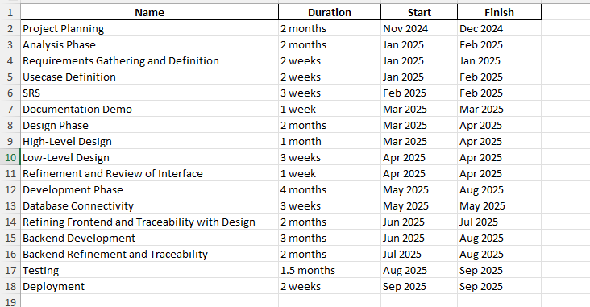
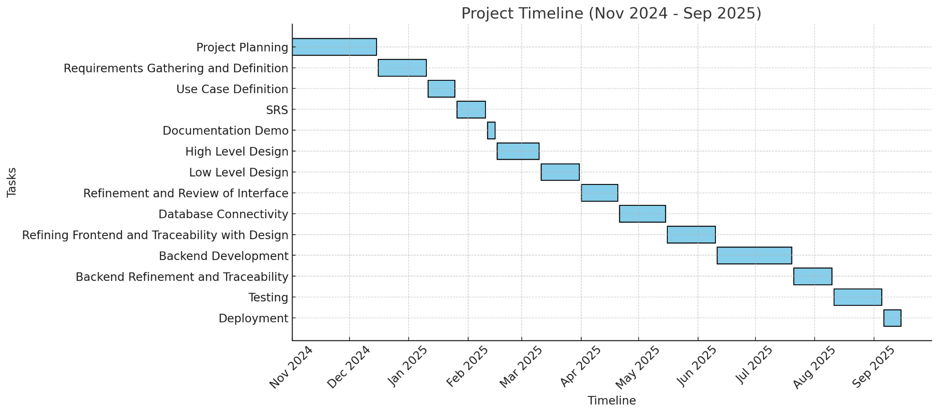

1.11 Risks and Contingencies
Risk ID | Risk Description | Risk Category | Likelihood | Contingency Plan
R1 | Real-time translation errors | Technical | High | Multiple translation APIs testing
R2 | Real-time voice-to-text transcription error | Technical | High | Multiple transcription APIs testing
R3 | Data breach or unauthorized access | Security | High | SSL, Encryption, authentication implementation
R4 | Server downtime affecting chat services | Operational | Medium | backup servers
R5 | latency in real-time translation and transcription | Technical | High | Optimize API calls, use WebSockets for faster processing, and implement local caching for common phrases

Chapter 2

Software Requirements Specification

2.0. Introduction
One of the most important documents in software development is the SRS document. It lays out how the system should work and acts as a roadmap for everyone involved. It helps turn an idea into clear, detailed instructions that developers can follow. It also serves as an agreement, outlining what the client needs and what the developers will deliver.

2.0.1 Purpose
This document defines the requirements for a Multilingual Web Chat System that enables real-time communication between users speaking different languages. The system will handle text and voice chat and automatically translate using the Google Translation API.

2.0.2 Definitions, Acronyms, and Abbreviations
- API: Application Programming Interface
- FR: Functional Requirement
- NFR: Non-Functional Requirement
- SSL: Secure Socket Layer
- UI: User Interface
- UX: User Experience
- SRS: Software Requirements Specification

2.1 Overall Description

2.1.1 Product Perspective
The system is a standalone web application that integrates with the Google Translation API for real-time language translation. It will be accessible via web browsers and will not require additional software installation.

2.1.2 Product Functions
- User Registration and Authentication
- Language Selection and Translation
- Text and Voice Messaging
- Voice Message Transcription, Translation
- Chat History and Search
- Group Chat Functionality
- Notifications
- User Profiles
- End-to-End Encryption

2.1.3 User Characteristics
Multilingual Web Chat System is designed for all kinds of users belonging to different age groups and with varying exposure to technology.

2.1.4 Constraints
- Translation API limits The free version of Google Translation API has usage restrictions.
- Internet dependency The system needs a stable internet connection for real-time translation.
- Latency issues Translations and transcriptions may have slight delays.
- Voice accuracy Speech-to-text transcription may not always be 100% accurate.

2.1.5 Assumptions and Dependencies
- Users have access to a stable internet connection.
- Google Translation API will be available and functional.

2.2 Specific Requirements

2.2.1 Functional Requirements (FR)
FR1: The system shall allow users to register and log in securely.
FR2: The system shall allow users to set their preferred language for communication.
FR3: Users shall be able to send and receive text messages.
FR4: The system shall automatically translate text messages into the recipient's language.
FR5: Users shall be able to send and receive voice messages.
FR6: The system shall translate voice messages.
FR7: Users shall be able to view past chat history.
FR8: The system shall allow users to search chat using keywords.
FR9: The system shall support group chats with real-time translation.
FR10: Users shall receive real-time notifications for incoming messages.
FR11: Users shall be able to customize their profiles with pictures and language preferences.

2.2.2 Non-Functional Requirements (NFR)

1. Performance
- NFR-2: Real-time translation must occur within 3 seconds for text messages.
- NFR-3: The chat interface must load within 2 seconds on a standard internet connection.

2. Security
- NFR-4: User passwords must be stored using hashing algorithms.

3. Usability
- NFR-7: The system must have a simple and intuitive UI/UX.
- NFR-8: The system must be compatible with Chrome and Edge browsers.

4. Reliability
- NFR-10: The system must have an uptime of 90% during the testing phase.
- NFR-11: Chat history must be stored for at least 30 days.

6. Maintainability
- NFR-14: The system must log errors for debugging purposes.

7. Compatibility
- NFR-15: The system must work on desktop and mobile browsers.

2.3 Major Inputs and Outputs

Inputs:
- Login Credentials (Email/Password)
- Preferred Language Selection
- Text Messages (Sent by Users)
- Voice Messages (Sent by Users)
- Images & Emojis
- Profile Information (Name, Profile Picture)
- Search Keywords (For Chat History)

Outputs:
- Translated Text Messages (Displayed in Recipient’s Preferred Language)
- Translated Voice Messages (Displayed as Text in Translated Transcription)
- Chat History Results (Based on User Search)
- User Profile Details
- Group Chat Messages (Translated in Real-time)
- Notification Alerts (For New Messages, Group Invites)

2.4. Use Case Diagram
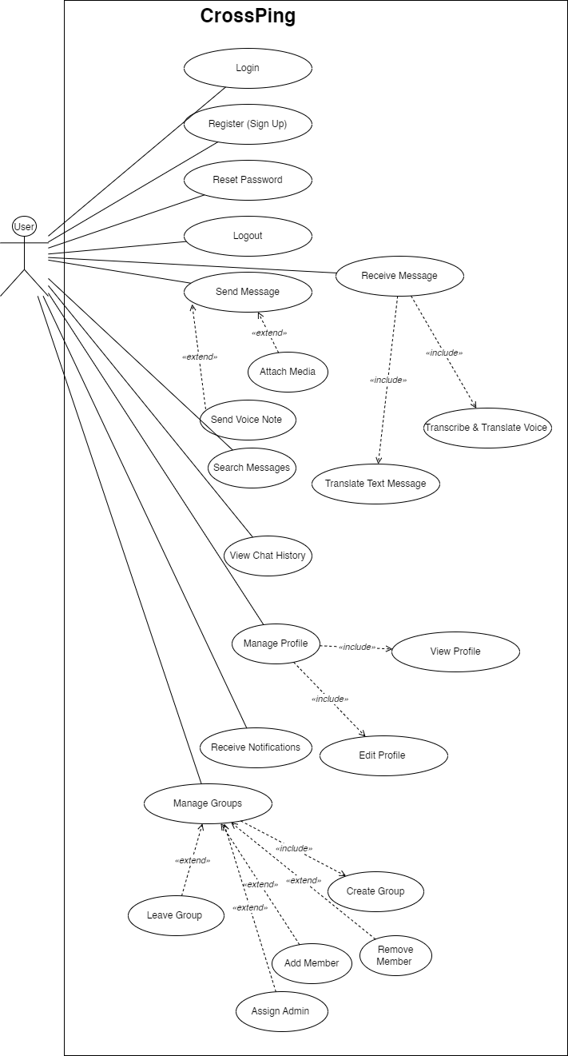
Fig.1.1 Use Case Diagram

2.4.1 Use Cases List

Authentication & User Management
- Login
- Signup
- Reset Password
- Logout
Messaging
- Send Text Message
- Receive Text Message
- Translate Text Message
- Send Voice Message
- Receive Voice Message
- Translate Voice Message
Chat Management
- View History
- Search by Keyword
- Create Group Chat
- Add/Remove Members
- Manage group admin
Notifications & Profile Management
- Send Notifications
- Customize Profile
- View Profile

2.5 Use Cases’ Description

2.5.1 Login
ID | UC1
Name | Login
Primary Actor | User
Pre-Condition | The user has a laptop, pc or mobile  The user has already signed up for an account  The user knows his password
Post Condition | The user has logged in to the web application successfully.  The system will redirect the user to connect Threads account page
Main Success Scenario | The user opens the app and clicks on the "Login" button  The system presents the login screen with email/username and password fields  The user enters their credentials and clicks "Login"  The system validates the credentials  The user successfully logs into the system and is redirected to the dashboard or home page
Alternative Flows | Invalid Input: If the user enters incorrect or incomplete information (e.g., invalid email, weak password), the system prompts them to correct it  Email Already Registered: If the email is already in use, the system asks the user to log in instead or use another email
Frequency | Occasionally

2.5.2 Sign Up
ID | UC2
Name | Sign up
Primary Actor | User
Pre-Condition | The user has access to the internet and a device (PC, mobile, etc.)
Post Condition | User successfully registers an account and is redirected to the login screen or home page
Main Success Scenario | The user opens the app and clicks on the "Sign Up" button  The system presents the signup form (name, email, password, etc.)  The user enters their details and click "Submit"  The system validates the details (e.g., email format, password strength)  The user successfully registers and is redirected to the login page or home page
Alternative Flows | Invalid Credentials: If the user enters the wrong password or email, the system prompts them to re-enter the credentials  Account Locked: If there are multiple failed login attempts, the system locks the account for a specified period and notifies the user
Frequency | Rarely (first-time users only)

2.5.3 Reset Password
ID | UC2.2
Name | Forgot Password
Primary Actor | User
Pre-Condition | User is on the login page and has forgotten their password
Post Condition | User successfully resets their password and is redirected to the login screen
Main Success Scenario | The user clicks on the "Forgot Password" link on the login page  The system prompts the user to enter their email address  The user enters their email and submits  The system sends a password reset link to the email address  The user clicks the link and is redirected to a page to create a new password  The user successfully sets a new password and is logged in automatically
Alternative Flows | Email Not Found: If the email is not registered, the system notifies the user and offers alternative options
Frequency | Occasionally

2.5.5 Set Language
ID | UC3
Name | Set Language
Primary Actor | User
Pre-Condition | User is logged in
Post Condition | The user’s preferred language is saved and displayed throughout the application
Main Success Scenario | - The user navigates to the settings  - User selects their desired language from the list of available languages  - The system updates the UI to reflect the selected language
Alternative Flows | Language Not Supported: The system informs the user if the chosen language is unavailable
Frequency | Occasionally

2.5.6 Send Text Messages
ID | UC4
Name | Send Text Messages
Primary Actor | User
Pre-Condition | The user is logged in, has an internet connection, and in an active chat conversation
Post Condition | The message is successfully sent
Main Success Scenario | The user types a message  The user clicks "Send"  The system transmits the message to the recipient
Alternative Flows | Message Not Sent: The system alerts user if there’s a network issue and prompts them to try again
Frequency | Frequently

2.5.7 Receive Text Messages
ID | UC4
Name | Receive Text Messages
Primary Actor | User
Pre-Condition | User is logged in and has an active internet connection
Post Condition | User receives the message
Main Success Scenario | User waits for an incoming message  System notifies the user of a new text message  User opens the chat to view the received message
Alternative Flows | The user waits for an incoming message  System notifies the user of a new text message  User opens the chat to view the received message
Frequency | Frequently

2.5.8 Automatic Translation of Text Messages

ID | UC5
Name | Automatic Translation of Text Messages
Primary Actor | User
Pre-Condition | Preferred language is chosen
Post Condition | Text message is automatically translated into the recipient’s language
Main Success Scenario | - User sends a message in their preferred language  - The system detects the recipient’s language preference  - System automatically translates the message into the recipient’s language  - Recipient receives the translated message
Alternative Flows | Translation Error: System notifies the user if translation fails due to connectivity or backend issue
Frequency | Frequently

2.5.9 Send Voice Messages
ID | UC6
Name | Send Voice Messages
Primary Actor | User
Pre-Condition | User is logged in and in an active chat conversation
Post Condition | Voice message is successfully sent
Main Success Scenario | User records a voice message  User clicks "Send"  System sends the voice message to the recipient
Alternative Flows | Audio Fail: System alerts user if audio is unavailable due to network issues
Frequency | Frequently

2.5.10 Translate Voice Messages
ID | UC7
Name | Translate Voice Messages
Primary Actor | User
Pre-Condition | User has received a voice message
Post Condition | Voice message is successfully translated to preferred language
Main Success Scenario | User listens to a voice message  System automatically transcribes the voice message
Alternative Flows | System notifies the user if translation fails
Frequency | Frequently

2.5.11 View Past Chat History
ID | UC7
Name | View Past Chat History
Primary Actor | User
Pre-Condition | User is logged in
Post Condition | User can view past chat conversation
Main Success Scenario | User navigates to the chat page  System displays a list of previous conversation
Alternative Flows | No History Available: System informs the user that no past conversations exist
Frequency | Ocassionally

2.5.12 Search Chat History
ID | UC8
Name | Search Chat History
Primary Actor | User
Pre-Condition | User is logged in and has chat history, enters keyword to search.
Post Condition | User can search and filter past conversations based on keyword
Main Success Scenario | User enters a search term in the search bar  System filters and displays the matching conversations
Alternative Flows | No Results Found: System displays a message that no results match the search query
Frequency | Ocassionally

2.5.13 Group Chat Creation
ID | UC9
Name | Group Creation
Primary Actor | User
Pre-Condition | User is logged in and have more than 0 contacts
Post Condition | A new group chat is created successfully, and the user is added to the group
Main Success Scenario | User clicks on the "Create Group" button from the dashboard or chat interface  The system prompts the user to provide a group name, select group language preferences, and add members (via search or contact list)  User enters the group name, selects the language for the group, and adds contacts to the group  User clicks "Create Group"  The system creates the group chat, adds the selected members, and applies language preferences  User is redirected to the newly created group chat
Alternative Flows | No Users Added: If the user does not select any contacts, the system will prompt them to add at least one contact to create the group  Group Creation Error: If there’s an issue creating the group (e.g., server failure), the system will show an error message
Frequency | Ocassionally

2.5.14 Add/ Remove members
ID | UC10
Name | Add/ remove members
Primary Actor | User (Group Admin)
Pre-Condition | User is a member of an existing group chat
Post Condition | Members are successfully added or removed from the group
Main Success Scenario | User opens the existing group chat  User clicks on the "Group Settings" button  System presents the option to add or remove members  User selects the contacts to add or remove  The system updates the group and notifies members about the changes
Alternative Flows | Permission Error: If the user is not an admin or does not have permission to add/remove members, the system will show a message explaining the error
Frequency | Ocassionally

2.5.15 Real-Time Notifications
ID | UC11
Name | Real-Time Notifications
Primary Actor | User
Pre-Condition | User is logged in and device is connected to internet.
Post Condition | User receives a notification for new messages
Main Success Scenario | User receives a message while offline or away from the app  System sends a push notification  User taps on the notification to view the message
Alternative Flows | Notification Failed: If notification fails, the user can manually check for new messages
Frequency | Frequently

2.5.16 Profile Customization

ID | UC11
Name | Profile Customization
Primary Actor | User
Pre-Condition | User is logged in and device is connected to internet.
Post Condition | Profile picture or status is updated
Main Success Scenario | User navigates to their profile page  User selects the option to edit profile  User uploads a new picture or changes status  User saves the changes
Alternative Flows | Profile Update Error: System alerts user if changes couldn't be saved due to network issue.
Frequency | Ocassionally

2.5.17 Logout

ID | UC12
Name | Logout
Primary Actor | User
Pre-Condition | User is logged in and device is connected to internet.
Post Condition | User is logged out of the application
Main Success Scenario | User clicks on the logout button  System logs the user out and redirects to the login screen
Alternative Flows | Logout Error: System alerts user if logout failed due to network or server issue
Frequency | Ocassionally

2.5.18 View Profile
ID | UC13
Name | View profile
Primary Actor | User
Pre-Condition | User is logged in and device is connected to internet.
Post Condition | The system displays the user’s profile information.
Main Success Scenario | The user opens the application.  The system displays the dashboard.  The user navigates to the profile section.  The system retrieves and displays the user’s profile details (name, email, profile picture, preferred language, and status).
Alternative Flows | Profile not displayed due to network issue
Frequency | Occasionally

2.6 System Sequence Diagrams

2.6.1 Login
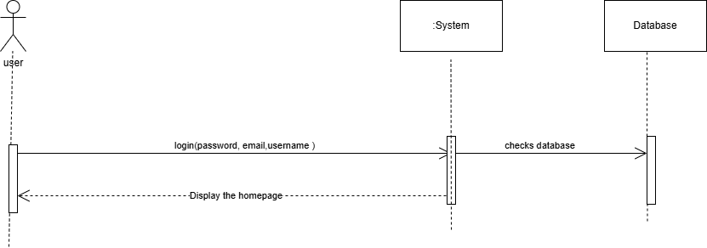
Fig.1.2 Login System Sequence

2.6.2 Signup
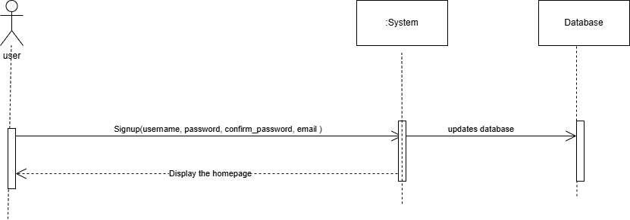
Fig.1.3 Signup System Sequence

2.6.3 Logout
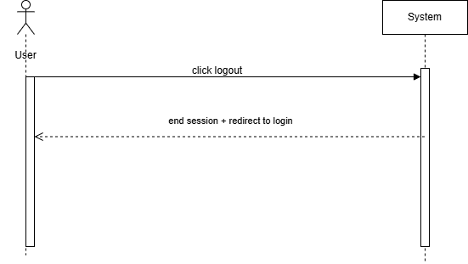
Fig.1.4 Logout System Sequence

2.6.4 Send Notifications
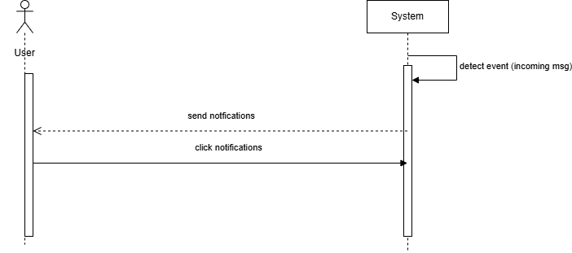

Fig.1.5 Send Notifications System Sequence

2.6.5 View Profile
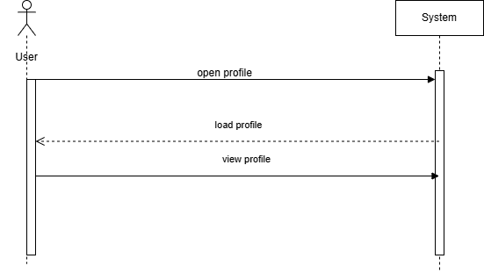

Fig.1.6 View Profile System Sequence

2.6.6 Add/Remove Members
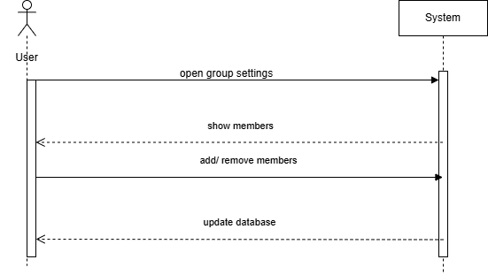
Fig.1.7 Add/Remove Members System Sequence

2.6.7 Create Group
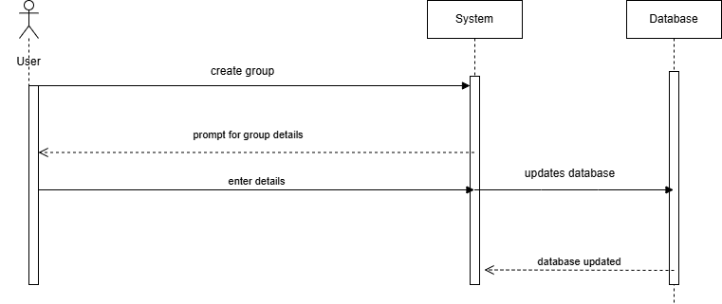
Fig.1.8 Create Group System Sequence

2.6.8 Search by Keyword
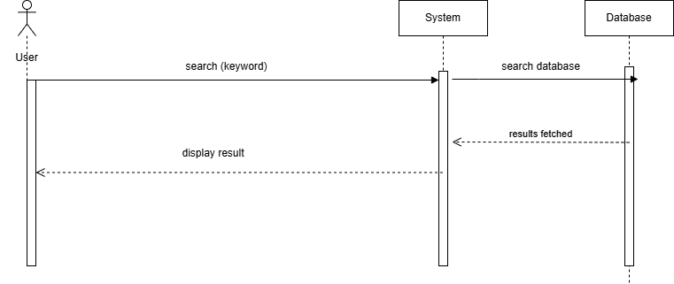
Fig.1.9 Search by Keyword System Sequence

2.6.9 View History
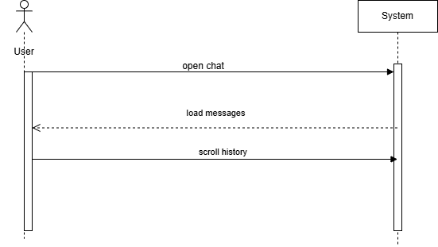
Fig.2.0 View History System Sequence

2.6.10 Recieve Message
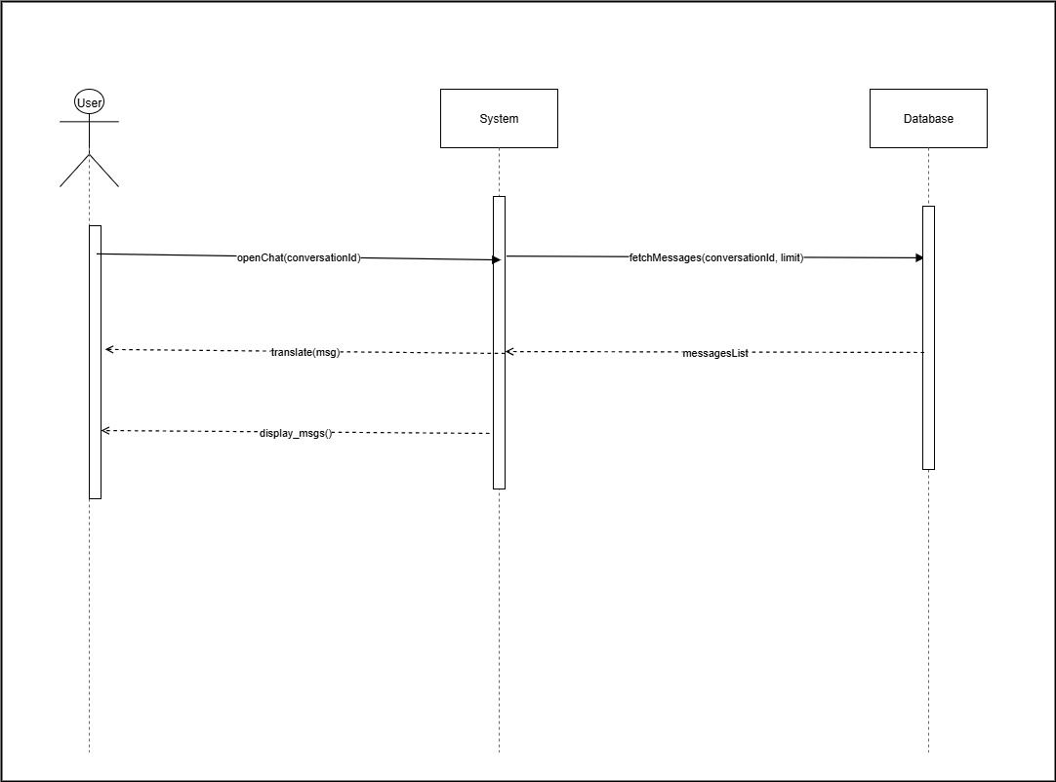
Fig.2.1 Receive Message System Sequence

2.6.11 Send Message
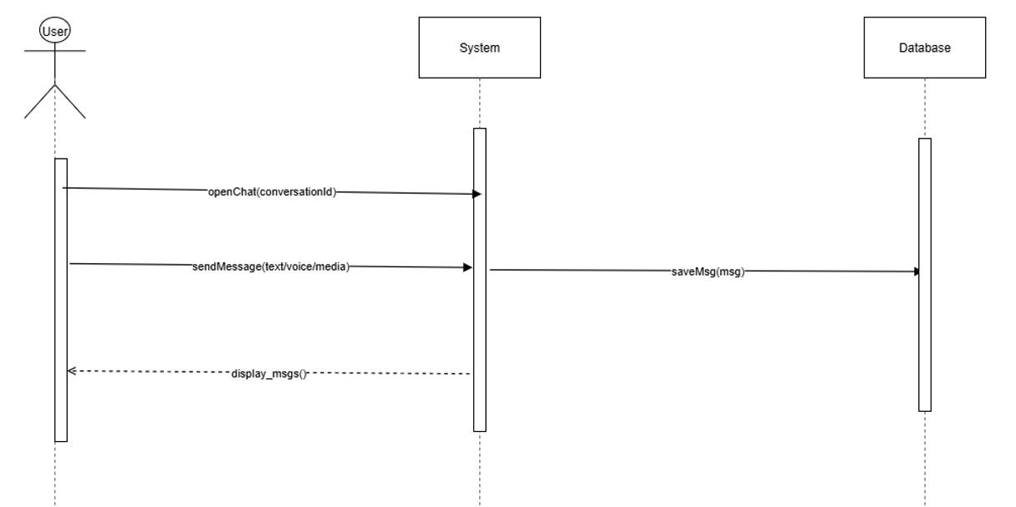
Fig.2.2 Send Message System Sequence

2.6.12 Set Language
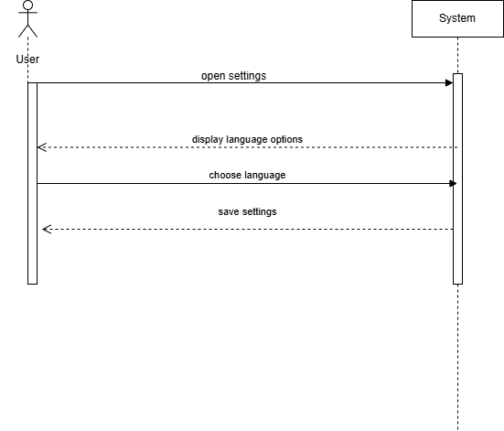
Fig.2.3 Set language System Sequence

2.6.13 Reset Password
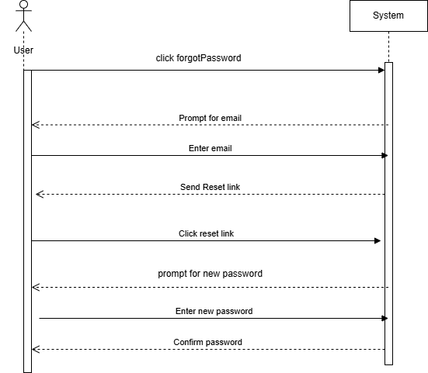
Fig.2.4 Reset Password System Sequence

2.7 Domain Model
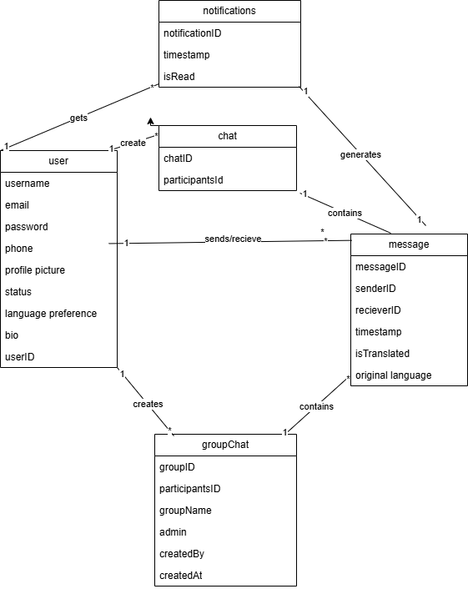
Fig.2.5 Domain Model

Chapter 3

Software Design Description

3.1. Introduction:
The Software Design Description (SDD) explains how the system is planned and organized. It gives a clear picture of the overall structure, how different parts work together, and how the system will meet the set requirements.

3.2. Purpose:
The goal of this document is to outline the design of the multilingual chat system and guide its development by showing what needs to be built and how it should be built.

3.3. Design Overview:
The Software Design Document presents a comprehensive, detailed description of the system's low-level structure and design for each of its components.

3.4 Chosen System Architecture:

3-tier architecture
Multilingual Web Chat System will be developed using 3-tier architecture. It has 3 different layers:

Presentation layer
This layer is responsible for presenting user interfaces to different users.

Application layer
It contains business logic and this layer processes requests of users from presentation layer.

Data layer
This layer is used to store and manage data of the system.

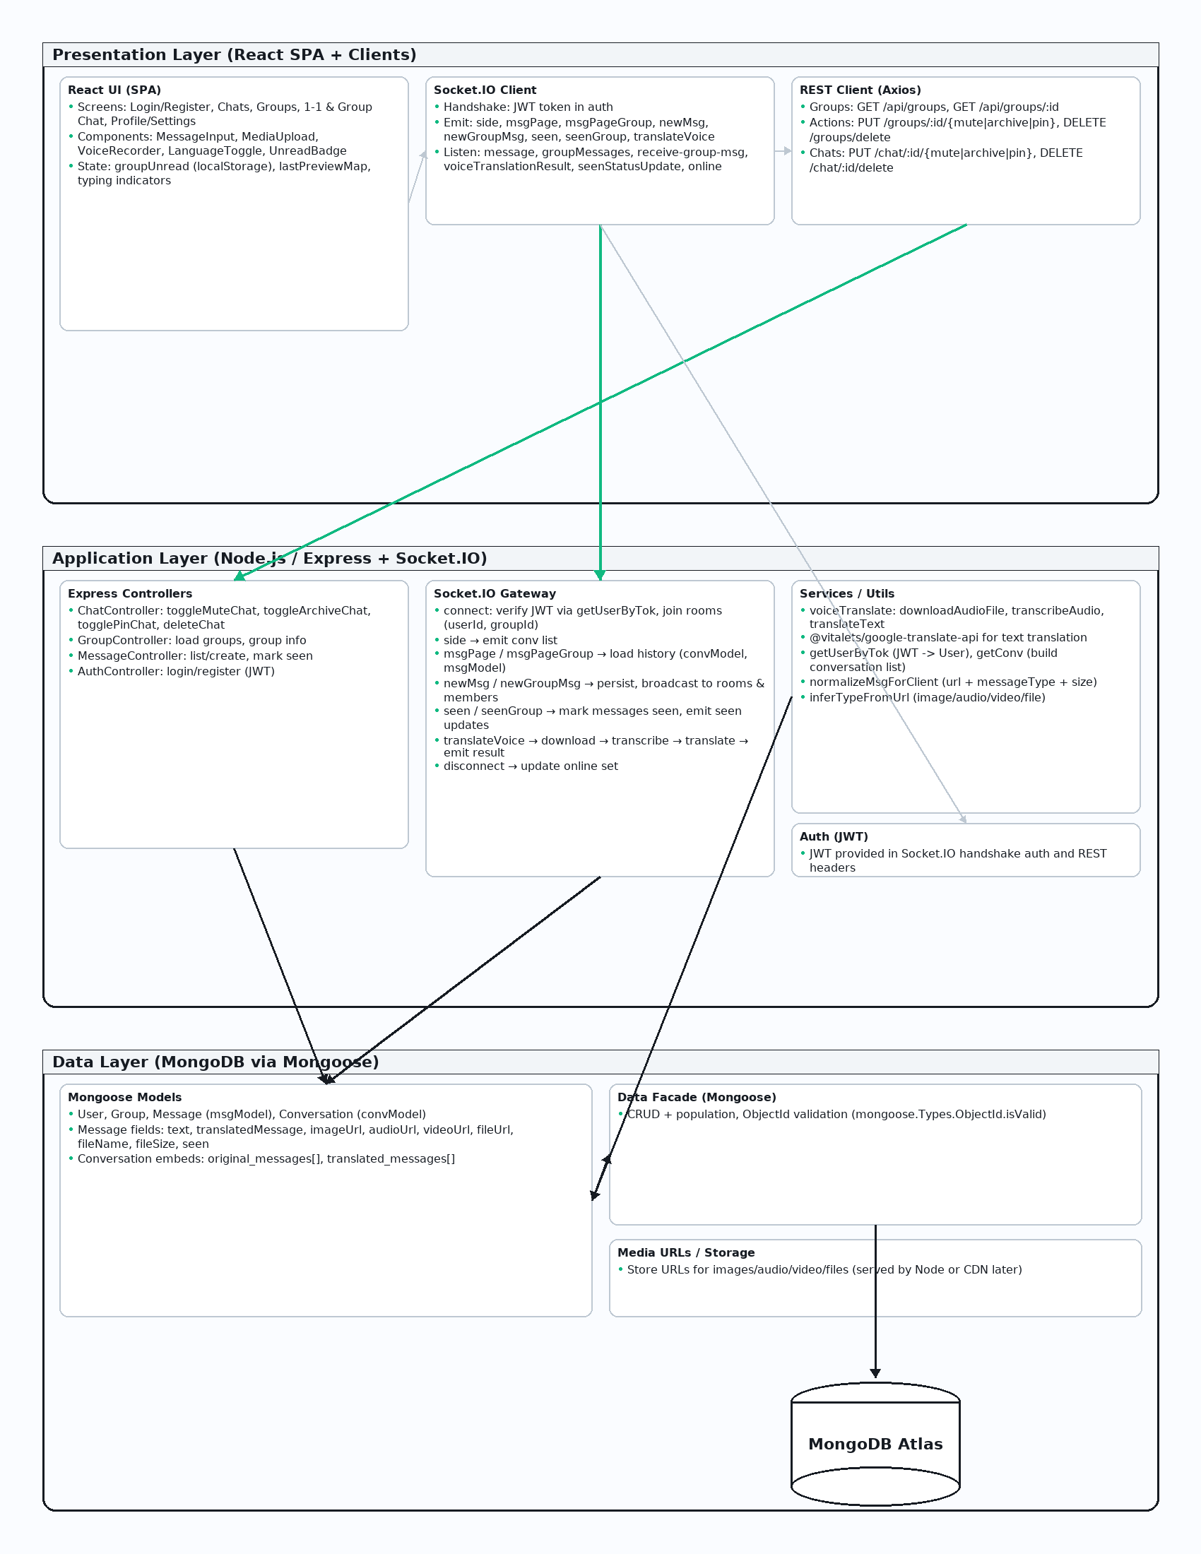
Fig.2.6 3-tier Architecture Diagram

3.5. System Interface Wireframes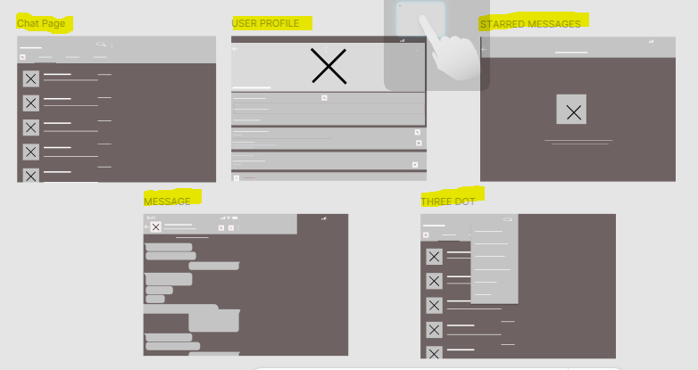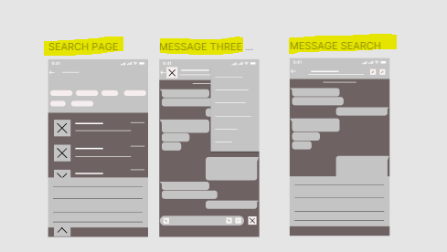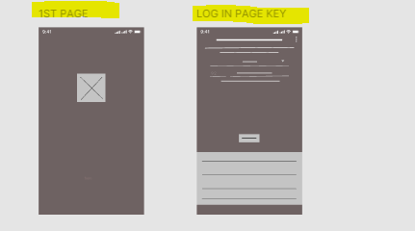

3.5.1 High Fidelity Design
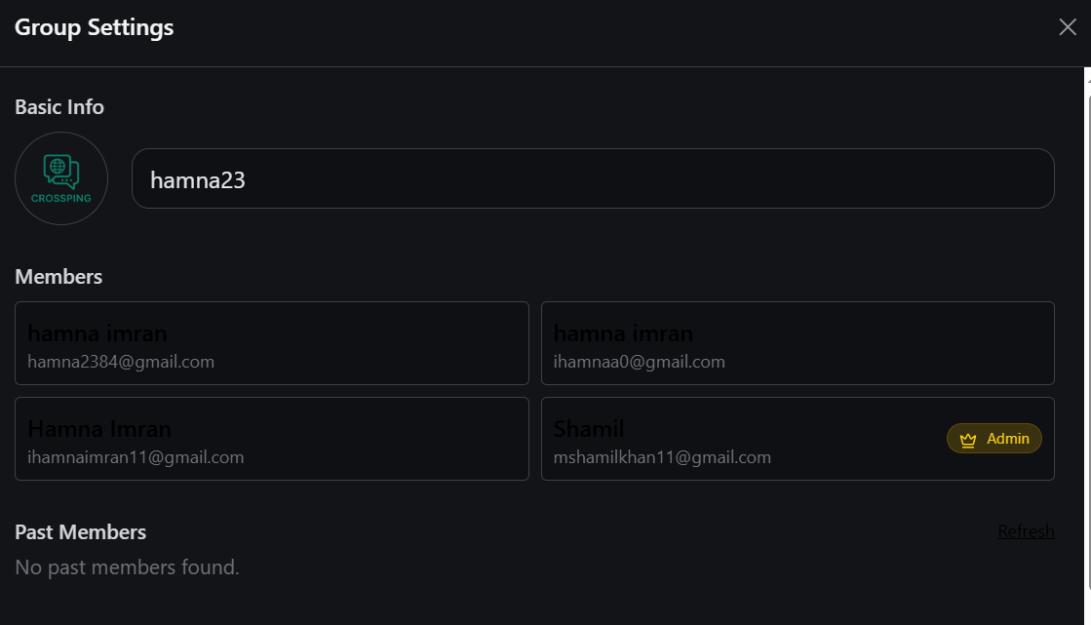
Group Settings page

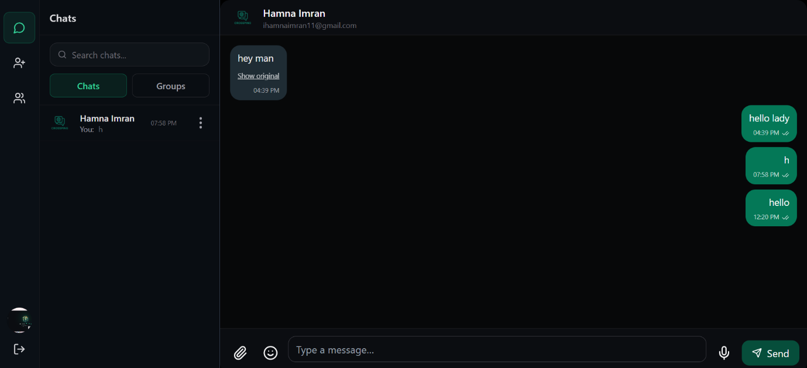
1-1 Chat page

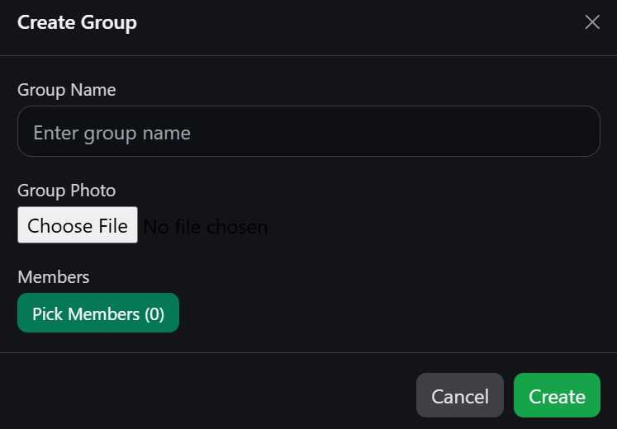
Create Group Modal page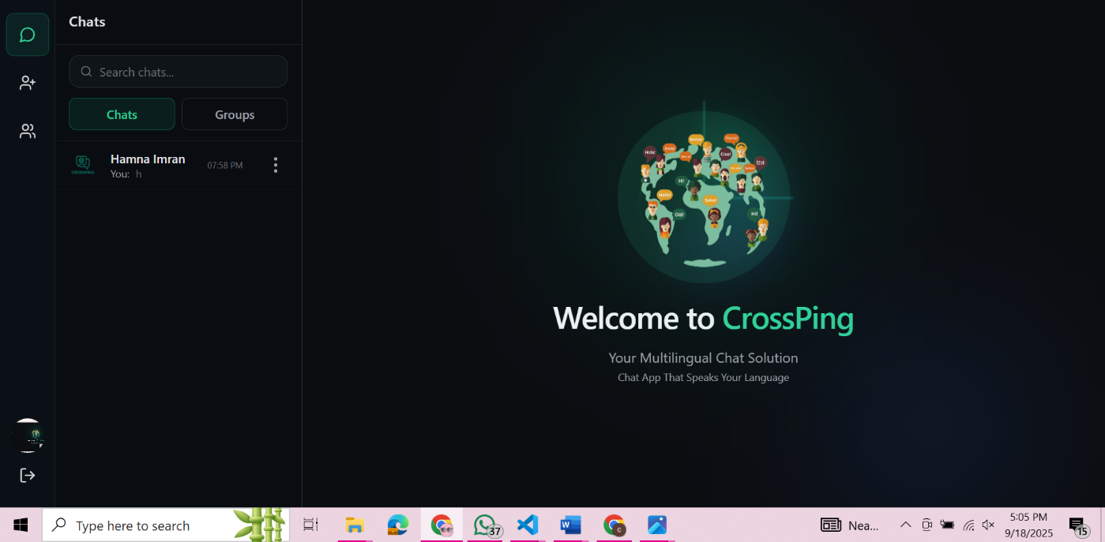 Homepage

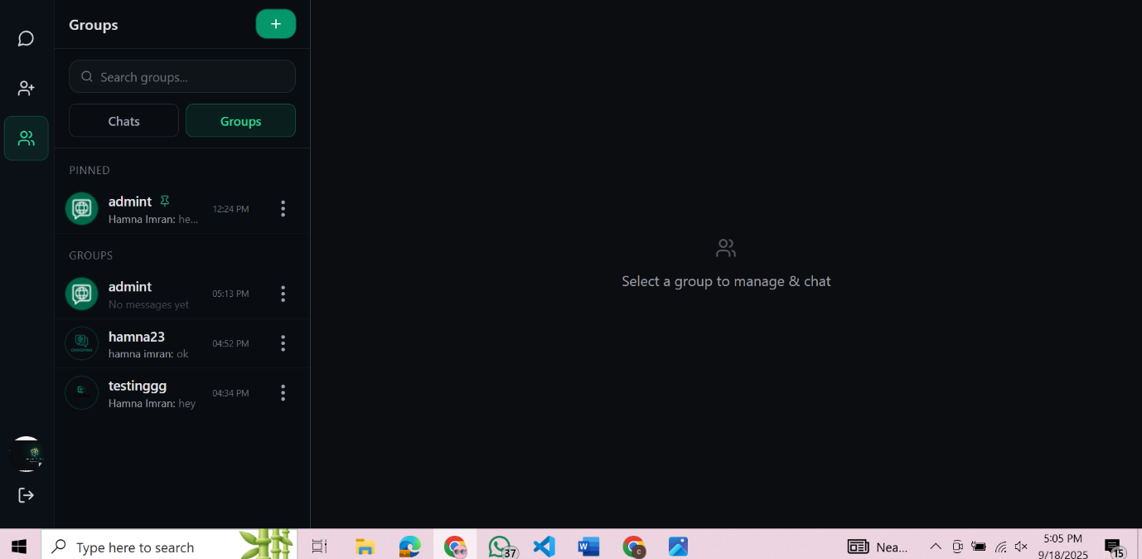 Groups page
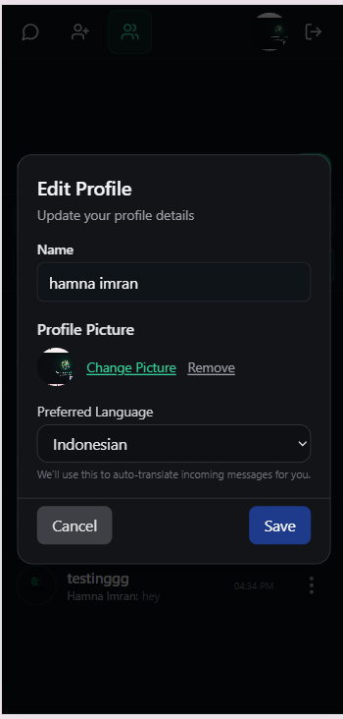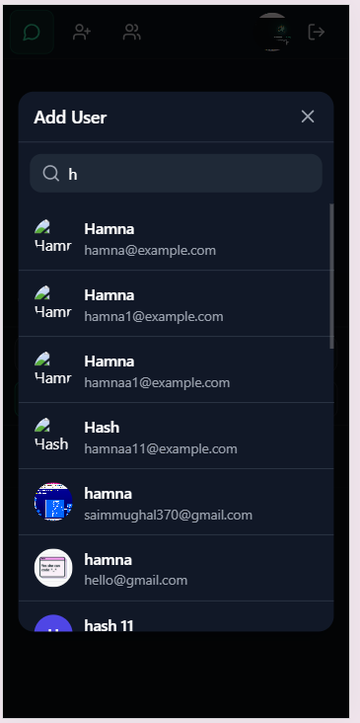
Profile Page and Add User

3.6. Database Design
3.6.1 ERD
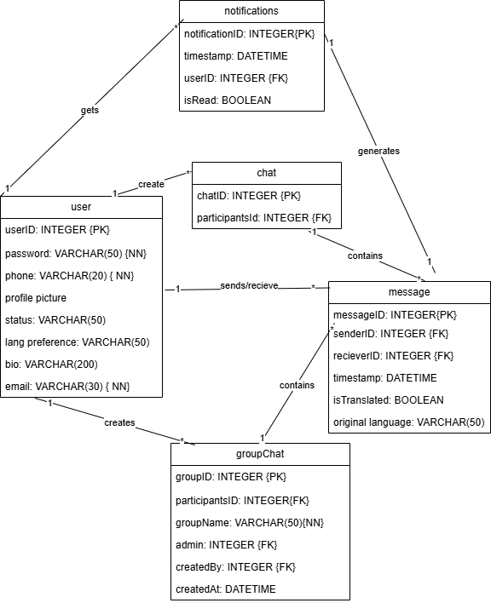

Fig.2.7 ERD

3.6.2 Schema Design
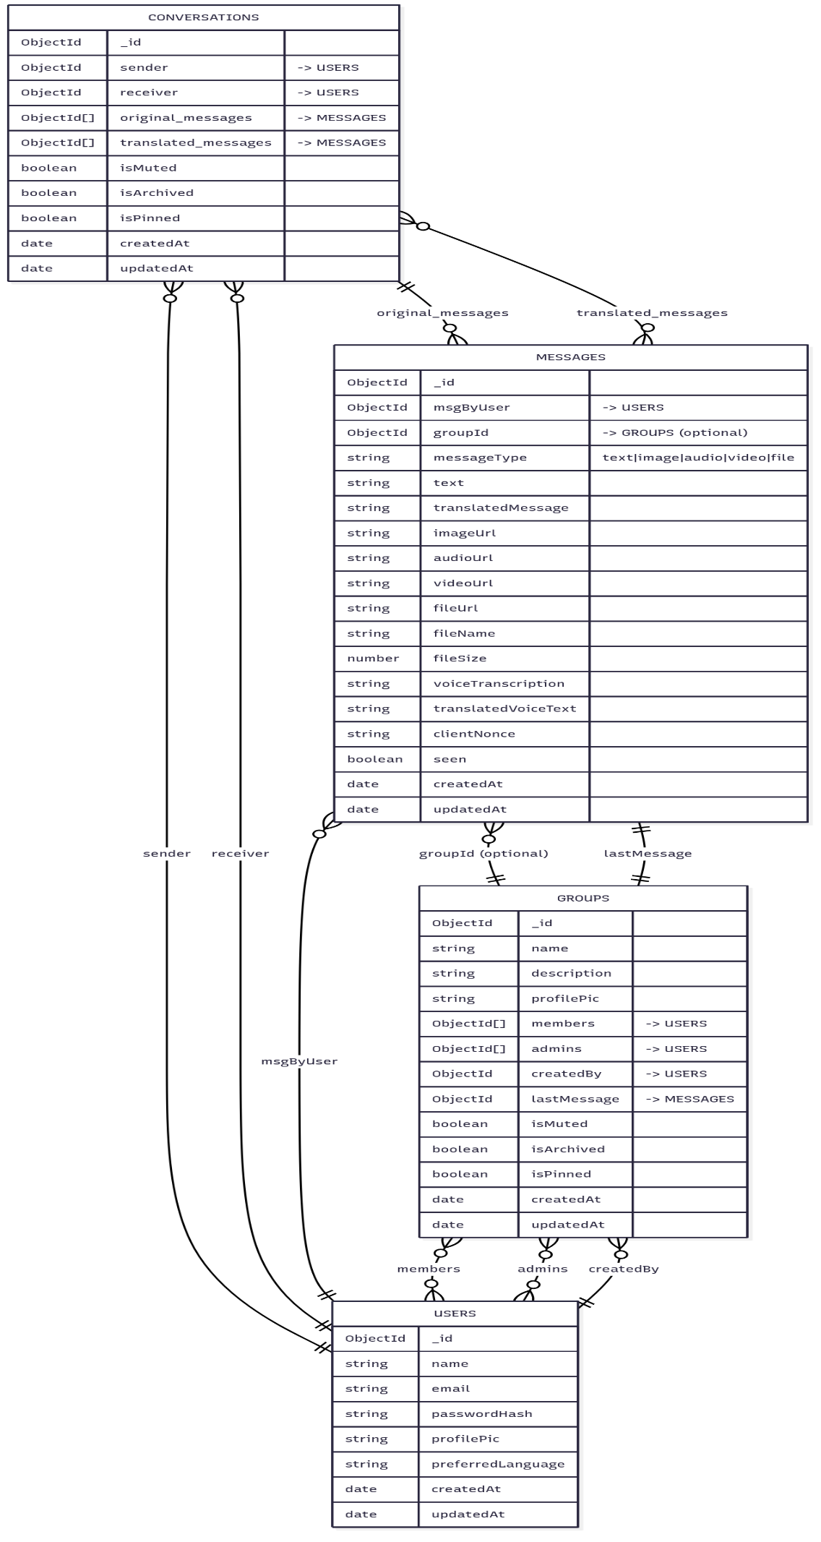
Fig.2.8 Database Schema

3.7. Sequence Diagrams

3.7.1 Login

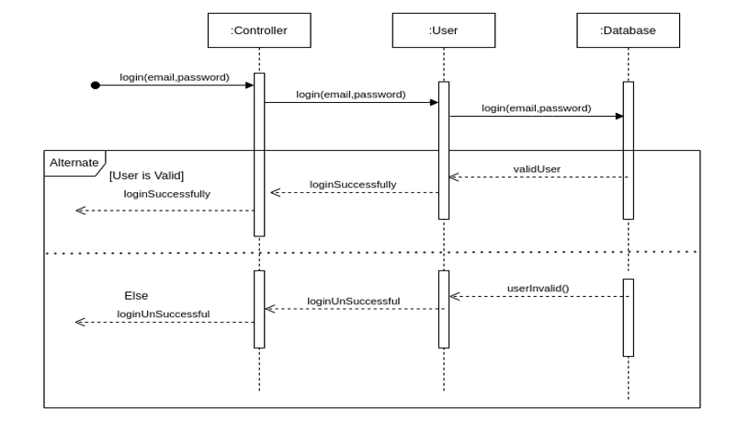
Fig.2.9 Login Sequence

3.7.2 Logout
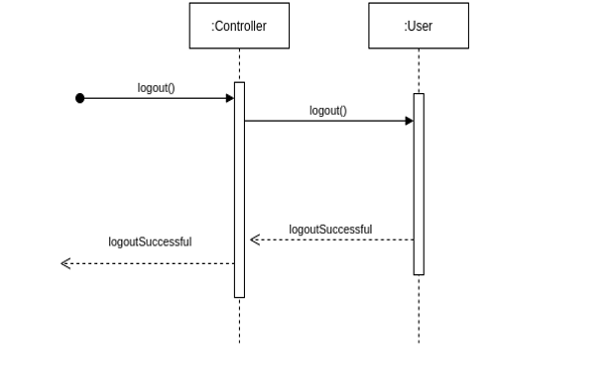
Fig.3.0 Logout Sequence

3.7.3 signup

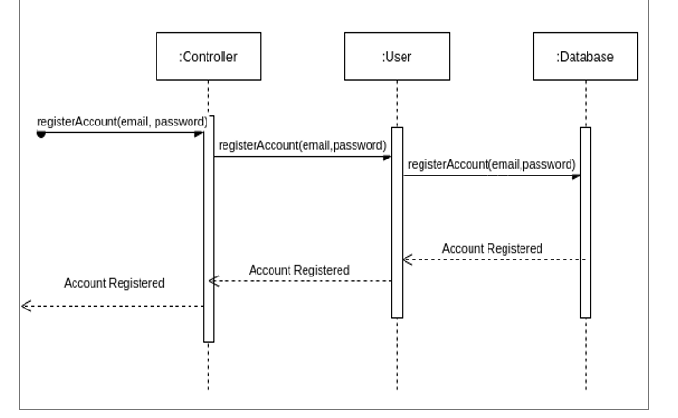

Fig.3.1 Signup Sequence

3.7.4 Send Message
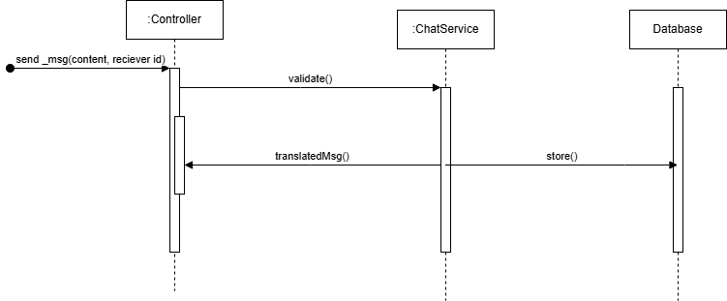
Fig.3.2 Send Message Sequence

3.7.5 Create Group
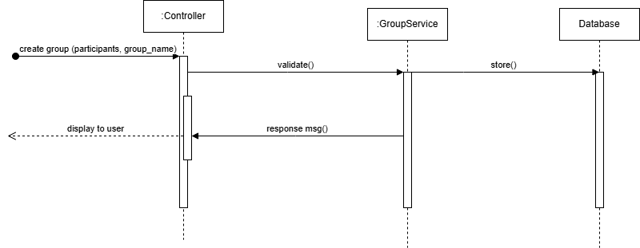

Fig.3.3 Create Group Sequence

3.8 Class Diagram
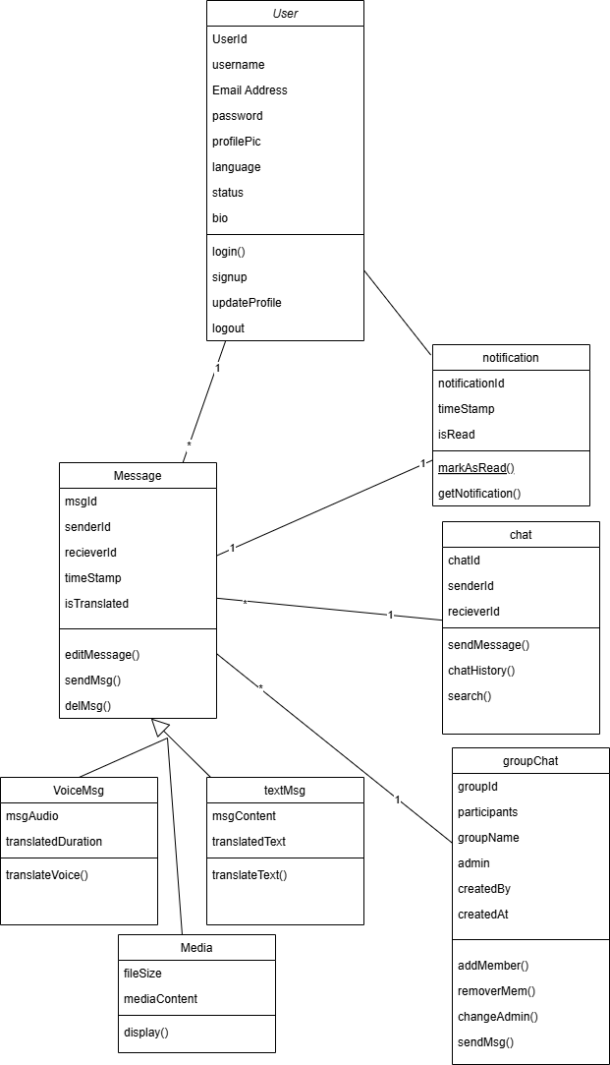

Fig.3.4 Class Diagram

Chapter 4

Implementation and Testing

4.1 Implementation:

1. Frontend Development with React.js
The frontend will be built using React.js. I’ll use socket.io-client for live updates, React Router for navigation, Axios for API calls, and lightweight utility components (icons, toasts, etc.). The list views show last-message previews (“You” or sender name), media badges (image/video/audio/file), and unread counters.

2. Backend Development with Node.js and Express.js

Express server hosts REST endpoints and a Socket.IO server for real-time chat. Clients authenticate by sending a JWT in the Socket.IO handshake; unauthorized sockets are rejected. The server normalizes and persists messages (text, image, audio, video, file), updates group/DM “last message”, emits live events (new message, typing, seen), and maintains online presence.

3. Database Management with MongoDB

Data is stored in MongoDB using Mongoose models

4. Version Control with Git and GitHub

All work is tracked with Git and hosted on GitHub for reviews, issue tracking, and collaboration.

5. API and Libraries Integration:
Socket.IO for real-time messaging. Translation via google-translate-api to auto-translate text and audio transcripts to the receiver’s preferred language.
Voice message is transcribed through Whisper API, then translated. All audio, media files are uploaded on Cloudinary and Cloudinary urls are saved in database.

4.2. Testing

4.2.1 Introduction
Software testing ensures that Multilingual Web Chat System is error-free, functions as expected, and delivers a smooth user experience. It plays a crucial role in verifying and validating the system’s reliability. Testing will be performed at every stage of development to maintain high quality.

4.2.2 Test Strategy
I’ll be doing the testing myself, so the plan is realistic and focused on catching issues that most affect users. I’ll be doing:
- Unit Testing: Testing individual components like messaging and profile updates.
- Integration Testing: Making smooth interaction between frontend, backend, and database.
Goals & Scope
Chat flows work reliably end-to-end (auth → chats → messages → notifications/seen states), that group permissions behave correctly, and that media/translation features don’t break the experience. I’ll prioritize high-impact bugs at this stage.

4.2.3 Features to be Tested
- Authentication & Session Management
- User Profile Management
- One-to-One Messaging
- Group Messaging
- Group Creation & Membership
- Group Admin Permissions
- Message Delivery & Reconnect
- Read Receipts (Seen)
- Unread Counters (Badges)
- Message Preview Prefix (“You/Name”)
- Text Messaging
- Image Messaging
- Video Messaging
- Audio Messaging
- File Sharing & Downloads
- Voice Transcription
- Message Translation Toggle
- Search (Chats & Groups)
- Pin / Mute / Archive (Chats & Groups)
- Input Validation
- Data Integrity (MongoDB State)

4.3. Test Cases
TC-01 Authentication & Session Management

Field | Details
Test Case ID | TC-01
Feature | Authentication & Session Management
Pre-conditions | User account exists server and MongoDB running
Test Data | (email: ihamnaimran11@gmail.com / password: Hamn@098);
Steps | 1) Open login page 2) Enter email & password 3) Click “Login” 4) Refresh browser 5) Close and reopen tab 6) Click “Logout”
Expected Result | Successful login creates session/JWT; user remains logged in after refresh; session restores user context (chats list) on reopen; logout clears token and redirects to login
Verdict | PASS

TC-02 User Profile Management

Field | Details
Test Case ID | TC-02
Feature | User Profile Management
Pre-conditions | Logged in as user1
Test Data | Name=“Hamna Imran”, Avatar=PNG <2MB
Steps | 1) Open Profile 2) Edit name 3) Upload avatar 4)Change Preferred language 5)Save 6) Refresh page 7) Re-login on another browser
Expected Result | Name and avatar update; persist across refresh and new session; avatar URL loads without 404
Verdict | PASS

TC-03 One-to-One Messaging
Field | Details
Test Case ID | TC-03
Feature | One-to-One Messaging
Pre-conditions | Users A and B are friends/connected; both online
Test Data | Message: “Hello B!”
Steps | 1) A opens chat with B 2) Send text 3) B observes message arrival
Expected Result | Message appears in A with “sent” status; B receives in <2s; timestamps consistent
Verdict | PASS

TC-04 Group Messaging
Field | Details
Test Case ID | TC-04
Feature | Group Messaging
Pre-conditions | Group G with A,B,C members; all online
Test Data | Message: “Standup at 10”
Steps | 1) A opens group G 2) Send text 3) B and C observe arrival
Expected Result | All members receive exactly once; order preserved; group last message updates
Verdict | PASS

TC-05 Group Creation & Membership
Field | Details
Test Case ID | TC-05
Feature | Group Creation & Membership
Pre-conditions | Logged in as A
Test Data | Group Name=“Techies”; Members=Hamna Imran, Shamil Khan
Steps | 1) Create group 2) Add B and C 3) Reopen group details 4) Remove C
Expected Result | Group created with unique ID; members list accurate; removed user loses access
Verdict | PASS

TC-06 Group Admin Permissions
Field | Details
Test Case ID | TC-06
Feature | Group Admin Permissions
Pre-conditions | Group G; A=admin, B=member
Test Data | Promote B to admin
Steps | 1) A opens group settings 2) Promote B 3) B removes C 4) B changes group name 5) Member C attempts to change name
Expected Result | Admins can promote/demote/update settings; non-admin blocked with proper error
Verdict | PASS

TC-07 Read Receipts (Seen)
Field | Details
Test Case ID | TC-07
Feature | Read Receipts
Pre-conditions | A->B chat with unread message
Test Data | N/A
Steps | 1) A sends message 2) B opens the chat thread 3) Observe read indicator at A
Expected Result | “Seen”/double-tick turns on when B views the thread
Verdict | PASS

TC-08 Unread Counters (Badges)
Field | Details
Test Case ID | TC-09
Feature | Unread Counters
Pre-conditions | A and B in 1:1; A has thread closed
Test Data | B sends 5 messages
Steps | 1) B sends messages 2) A’s sidebar shows count “5” 3) A opens thread 4) Count resets to 0
Expected Result | Badge increments accurately; resets on read for that thread only
Verdict | PASS

TC-09 Message Preview Prefix (“You/Name”)
Field | Details
Test Case ID | TC-10
Feature | Last Message Preview Prefix
Pre-conditions | A and B have recent messages
Test Data | A sends “On my way”
Steps | 1) A sends message 2) In chat list, A sees preview prefixed “You:” 3) B sees “A:”
Expected Result | Correct prefix appears per viewer/user context for 1:1 and group (use sender name in groups)
Verdict | PASS

TC-10 Voice Transcription

Field | Details
Test Case ID | TC-11
Feature | Voice Transcription
Pre-conditions | Transcription service enabled
Test Data | Clear 10-second English clip: “Meeting at ten”
Steps | 1) Send voice note 2) Toggle “Transcribe” 3) Verify text appears
Expected Result | Accurate transcription displayed; stored with message; toggle hides/shows
Verdict | PASS

TC-11 Message Translation Toggle
Field | Details
Test Case ID | TC-12
Feature | Message Translation Toggle
Pre-conditions | Translation API configured; A (English), B (Spanish)
Test Data | B sends “¿Cómo estás?”
Steps | 1) A receives message 2) Toggle “Translate” 3) See English translation 4) Toggle off
Expected Result | Correct translated text shown; original restored when off; indicator of source language
Verdict | PASS

TC-12 Search (Chats & Groups)
Field | Details
Test Case ID | TC-13
Feature | Search (Chats & Groups)
Pre-conditions | Multiple chats & groups with varying names
Test Data | Query: “Hamna”
Steps | 1) Open Search 2) Enter “Hamna” 3) View results 4) Click a result
Expected Result | Searched chats/groups displayed correctly
Verdict | PASS

TC-14 Pin / Mute / Archive (Chats & Groups)
Field | Details
Test Case ID | TC-14
Feature | Pin / Mute / Archive
Pre-conditions | At least 3 chats and 1 group
Test Data | N/A
Steps | 1) Pin Chat A 2) Mute Chat B 3) Archive Chat C 4) Receive new message in B & C 5) Refresh app
Expected Result | Pinned stays on top; muted receives silently/no badge; archived hidden from main list ,state persists after refresh
Verdict | PASS

Chapter 5

Conclusion and Future Work

5.1 Conclusion

The project delivers a simple and reliable multilingual chat system that makes conversations across languages effortless. It is secure, user-friendly, and built to adapt as future needs grow.

5.2 Future Enhancements
While the system meets its current requirements, there is always room for improvement and expansion. Some potential future enhancements include:
1. Mobile App
Build Android and iOS apps so users can stay connected anywhere with smooth performance and push notifications.
2. Message Reactions
Add quick emoji reactions and simple reply options
3. End-to-End Encryption
Strengthen privacy by ensuring only the sender and receiver can read messages.
4. Voice & Video Calls
Bring real-time conversations to life with one-to-one and group calling features.
5. AI Upgrades
Smarter translations, auto-suggested replies, and chat summaries to keep the app in line with modern trends.
6. More Languages
Expand language support by using paid APIs to cover wider global communication.
7. Personalization
Custom themes, and flexible notification settings for a more comfortable experience.
8. Scalability
Optimize performance and media handling so the app stays fast and reliable as more users join.

References
- Sommerville, I. (2015). Software Engineering (10th ed.). Pearson.
- Open AI API, Whisper documentation:
https://platform.openai.com/docs/models/whisper-1
- Google Translate API documentation:
https://cloud.google.com/translate/docs
- IEEE. (1998). IEEE Recommended Practice for Software Requirements Specifications (IEEE Std 830-1998).
- Pressman, R. S., & Maxim, B. R. (2020). Software Engineering: A Practitioner's Approach (9th ed.). McGraw-Hill.
- Pohl, K. (2010). Requirements Engineering: Fundamentals, Principles, and Techniques. Springer.
- Acceptance Testing. (2011). Retrieved from: http://softwaretestingfundamentals.com/acceptance-testing/

